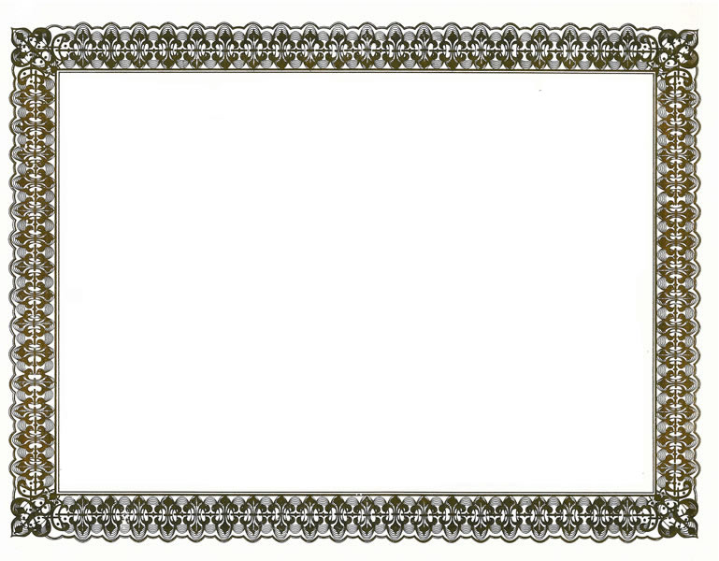


42nd Annual Meeting of the
Association for Computational Linguistics

Best Paper Award

Presented to

Diana McCarthy, Rob Koeling, Julie Weeds, & John Carroll

“Finding Predominant Word Senses in Untagged Text”

24 July 2004

Donia Scott, General Chair

Walter Daelemans, Program Co-chair

Marilyn Walker, Program Co-chair

DmiDmitriy Genzel, Co-chair

